**Java Project Report**

**on**

**Ragnarok Mage : Eternal Life**

**Submitted by**

**Chananvich Plabplathong 6031008921**

**[Nathabordine Wonghirundecha 6030183821](https://www.facebook.com/profile.php?id=100002442093116&ref=br_rs)**

**Subject**

**Course Programming Methodology Semester 1**



When launch the game you will see main menu that have 2 button to select.

You have to press arrow up and down, spacebar to select

Button Start: Start game

Button How to Play: You will go to How to play screen that introduce you to know how to move and attack, Monster’s information

**How to play Screen**

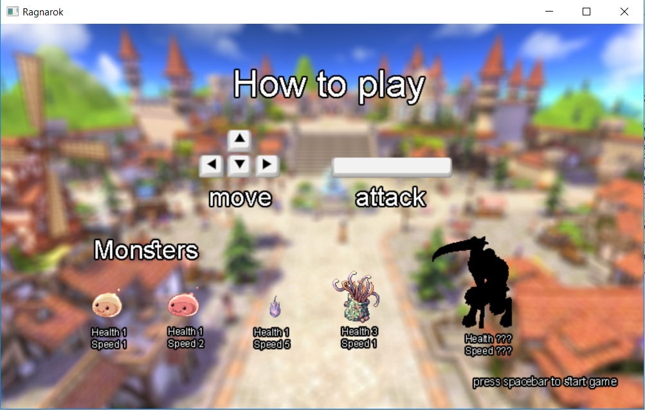

You can control the character by

**-** press ◄ to go left

**-** press ▲ to go up

**-** press ▼ to go down

**-** press ► to go right

- press spacebar to attack with fireball

Monster’s information shows its health and movement speed.

(Health mean how many you must attack it to kill.)

|  |  |  |
| --- | --- | --- |
| Name | Health | Speed |
| Drop | 1 | 1 |
| Poring | 1 | 2 |
| Horong | 1 | 5 |
| Hydra | 3 | 1 |
| ???(Boss) | ??? | ??? |

In this screen, if you press spacebar you will start game.

When you select Start button

-go to Game screen.

- You control the character called Mage that have 10 life point.

- Mage start at middle of map.

- Monsters spawn with random position. (2 sec per mons)

- If monster touch Mage you will lose 1 life point.

- you can kill many monsters with fireball.

- When Mage level up a new monster has born.

- Eliminate the boss to win this game

**Game screen**

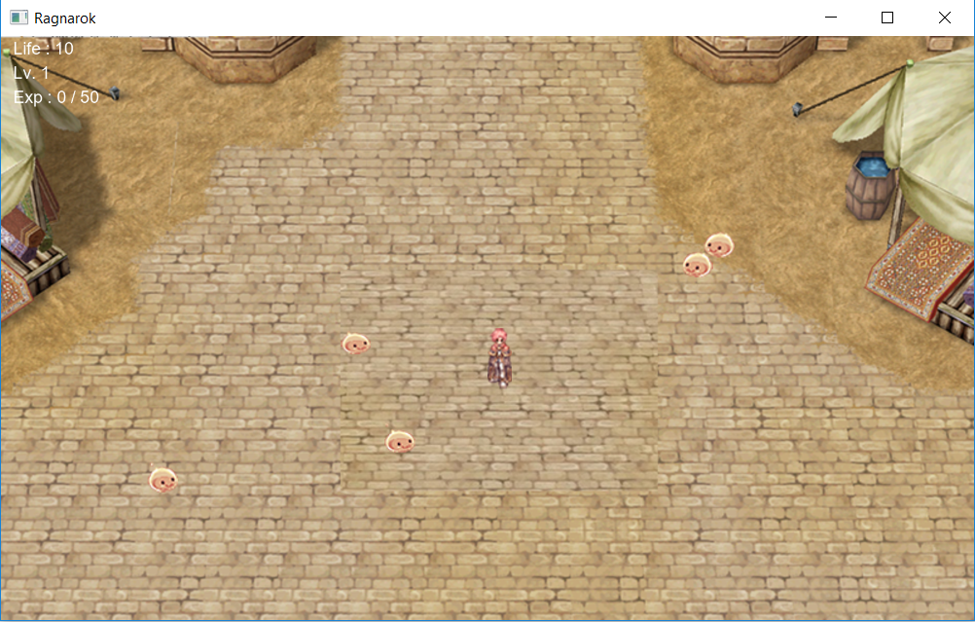

- You control the character called Mage that have 10 life point.

- Mage start at middle of map.

- Monsters spawn with random position. (2 sec per mons)

- If monster touch Mage you will lose 1 life point.

- you can kill many monsters with fireball.

- When Mage level up a new monster has born.

- Eliminate the boss to win this game

If you die (0 life points) you will go to dead scene

**Dead scene**

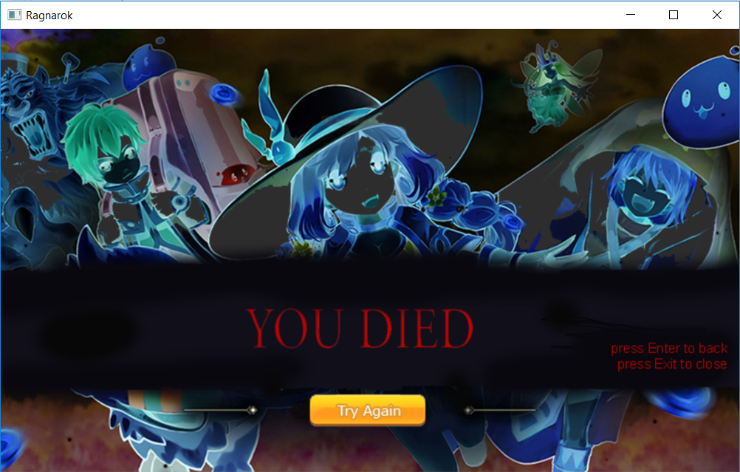

Press Enter to back to Main menu.

Press Esc to close game.

If you kill a boss it will go to win scene

**Win scene**

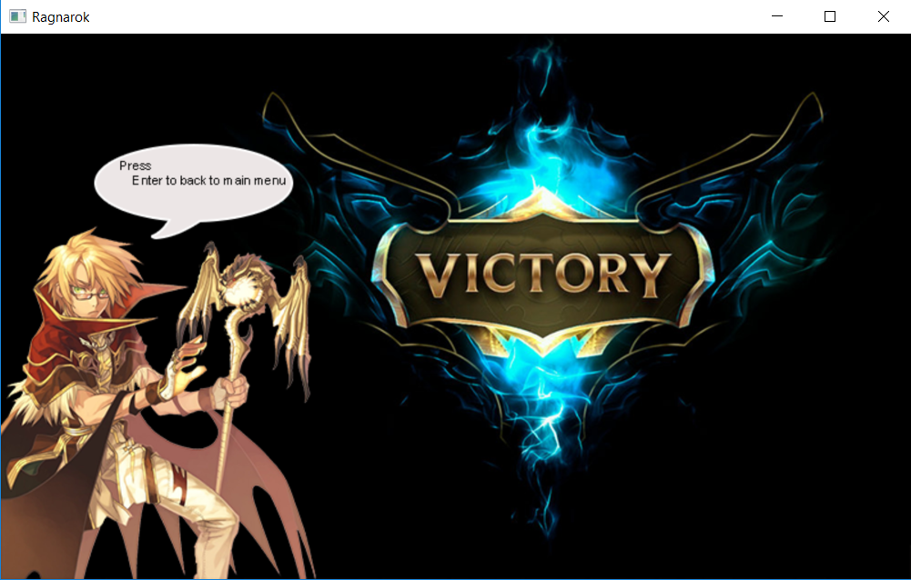

Press Enter to back to main menu.

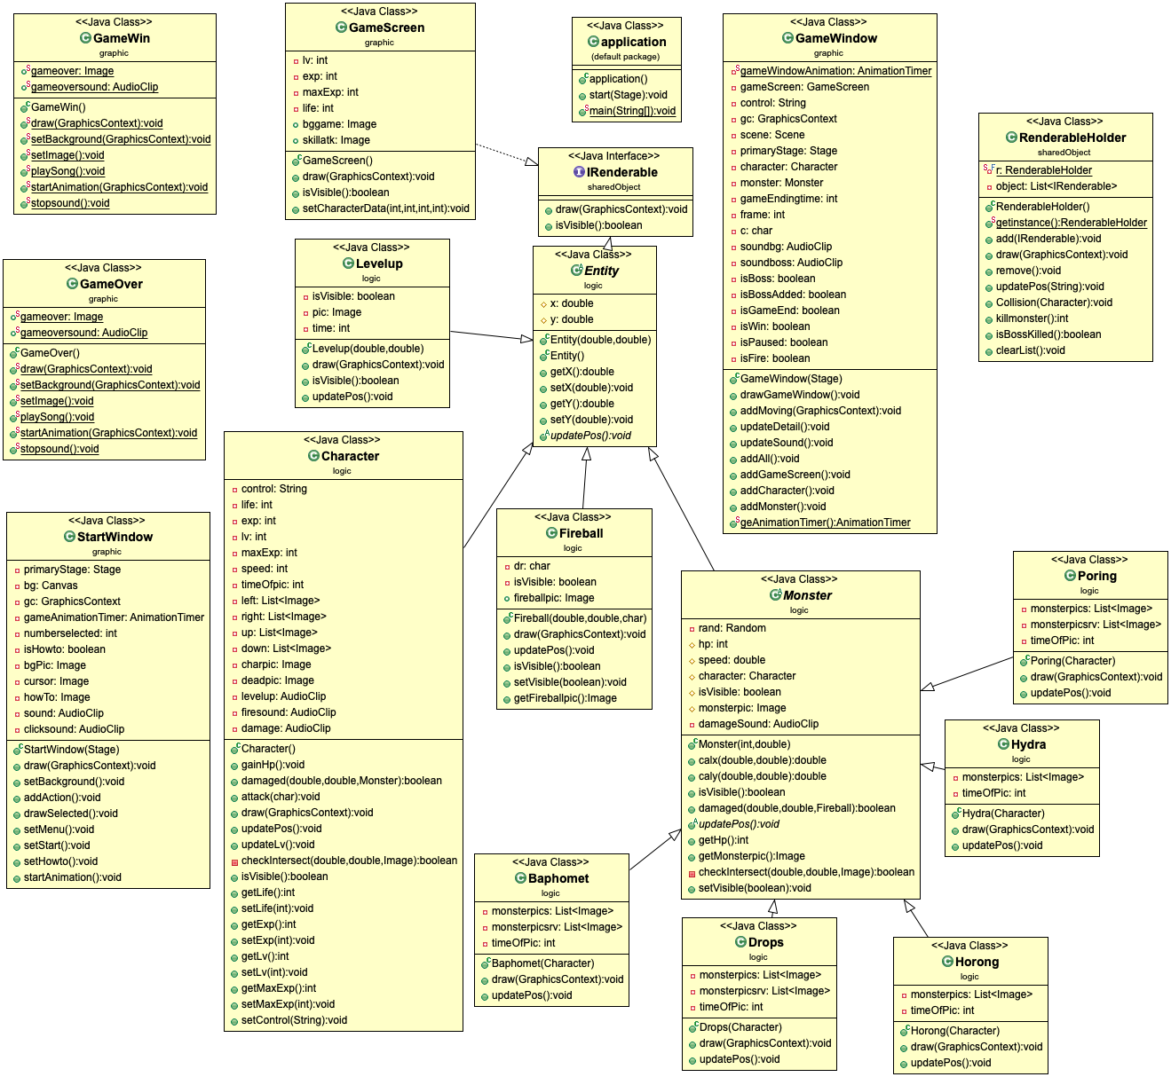

**An UML Diagram of Project**

* Noted that Access Modifier Notations can be listed below

+ (public)

# (protected)

- (private)

**Class Detail:**

**1. Package (default package)**

1.1 Class application

1.1.1 Methods

|  |  |
| --- | --- |
| + void start | The main entry point for the JavaFX applications |
| + void main | An entry point of the application |

**2. Package graphic**

2.1 Class GameWindow extends Canvas

2.1.1 Field

|  |  |
| --- | --- |
| - static AnimationTimer gameWindowAnimation | a timer in each frame |
| - GameScreen gameScreen | Background screen |
| - String control | Char contain Keycode  /* default set it to empty String*/ |
| - GraphicsContext gc | Stack of Objects will be rendered to image |
| - Scene scene | Any screen |
| - Stage primaryStage | First stage of program |
| - Character character | Character(player) |
| - Monster monster | Monster(enemy) |
| - int gameEndingtime | When game is end. prolong a screen  /* default is 50*/ |
| - int frame | Timer |
| - Char c | Contain keyCode |
| - AudioClip soundBG | Sound during play the game |
| - AudioClip soundBoss | Sound when baphomet has  born |
| - boolean isBoss | Check it is baphomet |
| - boolean isBossAdded | Check baphomet has arrive? |
| - boolean isGameEnd | Check that end |
| - boolean isWin | Check that win |
| - boolean isPause | Check that paused |
| - boolean isFire | Check that attack |

2.1.2 Constructor

|  |  |
| --- | --- |
| + GameWindow(Stage primaryStage) | - set stage  - create canvas that Width is 800 and height is 480  - set GraphicsContext2D  - get soundBG and soundBoss  - play soundBG |

2.1.3 Methods

|  |  |
| --- | --- |
| + void drawGameWindow() | - Call addMoving method  - set gameWindowAnimation |
| + void addMoving(GraphicsContext gc) | set value of c belong keyEvent  - press left set it ‘A’  - press right set it ‘D’  - press up set it ‘W’  - press down set it ‘S’  press spacebar set isfire is true and character attack  press Esc to close the game  press P to pause the game |
| + void updateDetail() | All update |
| + void updateSound() | If screen is changed.sound will change too |
| + void addAll() | call GameScreen,Character and Monster method |
| + void addGameScreen() | Add new screen |
| + void addCharacter() | Add new character frame |
| + void addMonster() | Generate new monster depend on Character’ level |
| + static AnimationTimer getAnimationTimer() | Return gameAnimationWindow |

2.2 Class StartWindow

2.2.1 Field

|  |  |
| --- | --- |
| - Stage primaryStage | First screen of program |
| - Canvas bg | The area to draw |
| - GraphicsContext gc | Drawer |
| - AnimationTimer gameAnimationTimer | Timer in each frame |
| - int numberSelected | In main menu  Start button is 0  How to play is 1  If you press down it will be 1  If you press uo it will be 0  /* default is 0*/ |
| - boolean isHowto | Check this screen is How to play screen |
| - Image bgPic | Background |
| - Image cursor | It show your selected button |
| - Image howTo | How to play screen’s background |
| - AudioClip sound | Main menu music |
| - AudioClip clickSound | Sound play when you press spacebar |

2.2.2 Constructor

|  |  |
| --- | --- |
| StartWindow(Stage primaryStage) | - set stage  - create canvas that Width is 800 and height is 480  - set GraphicsContext2D  - get clickSound and sound  - play sound |

2.2.3 Methods

|  |  |
| --- | --- |
| + void draw(GraphicsContext gc) | - set title and scene from gc  - start timer |
| + void setBackground() | - add image to background |
| + void addAction() | - Press up and down to change button  - Press spacebar to select  - Press P to pause the game  - Press Esc to close program |
| + void drawSelected() | Draw cursor next to selected button |
| + void setMenu() | call setStart and setHowto method |
| + void setStart() | Draw Start button |
| + void setHowto() | Draw How to play |
| + void startAnimation() | Call graphicsContext |

2.3 Class GameScreen implements IRenderable

2.3.1 Field

|  |  |
| --- | --- |
| - int lv | Level of character |
| - int exp | An experience point to level up |
| - int maxExp | Amount of exp for next level |
| - int life | Life point. If it 0 you will defeated |
| - Image BGgame | Background image |

2.3.2 Constructor

|  |  |
| --- | --- |
| + GameScreen() | add image to BGgame |

2.3.3 Methods

|  |  |
| --- | --- |
| + void draw(GraphicsContext gc) | - Draw BGgame,  - Draw Life, Lv,exp/maxExp in Left-top of screen |
| + boolean isVisible() |  |
| + void setCharacterData(int lv, int exp, int maxexp, int life) | Set field |

2.4 Class GameOver

2.4.1 Field

|  |  |
| --- | --- |
| + static Image gameOver | GameOver’s background |
| + static AudioClip gameOversound | GameOver’s music |

2.4.2 Constructor

|  |  |
| --- | --- |
| + GameOver() | add music to gameOversound |

2.4.3 Methods

|  |  |
| --- | --- |
| + static void draw(GraphicsContext gc) | Call setImage, playSong and setBackground method |
| + static void setBackground(GraphicsContext gc) | Draw gameOver |
| + static void setImage() | Set image of gameOver |
| + static void playSong() | Play gameOversound |
| + static void startAnimation(GraphicsContext gc) | call  **graphicsContext** |
| + static void stopsound() | Stop gameOversound |

2.5 Class GameWin

2.5.1 Field

|  |  |
| --- | --- |
| + static Image gameWin | gameWin’s background |
| + static AudioClip gameWinSound | gameWin’s music |

2.5.2 Constructor

|  |  |
| --- | --- |
| + GameWin() | add music to gameWinSound |

2.5.3 Methods

|  |  |
| --- | --- |
| + static void draw(GraphicsContext gc) | Call setImage, playSong and setBackground method |
| + static void setBackground(GraphicsContext gc) | Draw gameWin |
| + static void setImage() | Set image of gameWin |
| + static void playSong() | Play gameWinSound |
| + static void startAnimation(GraphicsContext gc) | Call graphicsContext |
| + static void stopsound() | Stop gameWinSound |

3. Package logic

3.1 Abstract class Entity implements IRenderable

3.1.1 Field

|  |  |
| --- | --- |
| # double x | X position |
| # double y | Y position |

3.1.2 Constructor

|  |  |
| --- | --- |
| + Entity() |  |
| + Entity(double x, double y) | Set x and y |

3.1.3 Methods

|  |  |
| --- | --- |
| + abstract void updatePos() | /*abstact method */  Check recently position x and y |
| + Getter & Setter methods for every field |  |

3.2 Class Character extends Entity

3.2.1 Field

|  |  |
| --- | --- |
| - String control | keyCode |
| - int life | Life point is 10 |
| - int exp | An experience point to level up |
| - int lv | **Level of character** |
| - int maxExp | **Amount of exp for next level**  **/*level has 50 and increase 10 each level** |
| - int speed | Movement speed of character |
| - int timeOfpic | Range time by frame of picture |
| - List<Image> left | List of image that show character move -x positon |
| - List<Image> right | List of image that show character move +x positon |
| - List<Image> up | List of image that show character move +y positon |
| - List<Image> down | List of image that show character move -y positon |
| - Image charpic | Character’s picture |
| - Image deadpic | Dead character’s picture |
| - AudioClip levelup | Sound that play when level up |
| - AudioClip firesound | Fireball sound that play when attack |
| - AudioClip damage | Sound that play when character has been attacked |

3.2.2 Constructor

|  |  |
| --- | --- |
| + Character() | - Set character position in middle of screen(400x240)  - set life, lv, maxExp and speed  - add left, right, up, down, charpic and deadpic image  - set levelup,firesound and damage sound |

3.2.3 Methods

|  |  |
| --- | --- |
| + void gainHp() | Increase 1 life |
| + boolean damaged(double x, double y, Monster monster) | If monster touch character. character lose 1 life  (both position is same) |
| + void attack(char c) | Character shoot fireball from its position |
| + void draw(GraphicsContext gc) | Call graphicsContext |
| + void updatePos() |  |
| + void updateLv() | If exp has enough level will be inceased |
| - boolean checkIntersect(double x, double y, Image pic) | Check character position is equal than x,y |
| + boolean isVisible() |  |
| Getter & Setter methods for life, Exp, maxExp, Lv and Control |  |

3.3 Class Fireball extends Entity

3.3.1 Field

|  |  |
| --- | --- |
| - char dr | keyCode |
| - boolean isVisible | /*default boolean is true*/ |
| + Image fireballpic | Fireball’s picture |

3.3.2 Constructor

|  |  |
| --- | --- |
| + Fireball(double x, double y, char dr) | Set image depend on dr |

3.3.3 Methods

|  |  |
| --- | --- |
| + void draw(GraphicsContext gc) | Draw fireball |
| + void updatePos() | Update fireball’s position depend on dr |
| + Getter & Setter on isVisible and fireballpic |  |

3.4 Class Levelup extends Entity

3.4.1 Field

|  |  |
| --- | --- |
| - boolean isVisible | /* default boolean is true*/ |
| - Image pic | Level up’s picture |
| - int time | Range time of pic (set it 100) |

3.4.2 Constructor

|  |  |
| --- | --- |
| + Levelup(double x, double y) | - set x, y and pic |

3.4.3 Methods

|  |  |
| --- | --- |
| + void draw(GraphicsContext gc) | - Draw fireball and decrease a time  - if time is 0. Fireball is disappear |
| + boolean isVisible() |  |
| + void updatePos() |  |

3.5 Class Monster extends Entity

3.5.1 Field

|  |  |
| --- | --- |
| # Image monsterpic | Monster’s picture |
| # int hp | Monster’s life |
| # double speed | Monster’s movement speed |
| # Character character | Character |
| # boolean isVisible | /* default boolean is true */ |
| - Random rand | Random number for different position |
| - AudioClip damageSound | sound that play when monster takes damage |

3.5.2 Constructor

|  |  |
| --- | --- |
| + Monster(int hp, double speed) | - set position x, y, hp, speed and damageSound |

3.5.3 Methods

|  |  |
| --- | --- |
| + double calx(double x, double y) | Calculate x to approach other character |
| + double caly(double x, double y) | Calculate y to approach other character |
| + Image getMonsterpic() | Return monsterpic |
| + boolean damaged(double x, double y, Fireball fireball) | If fireball touch monster. Monster lose 1 life  (both position is same) |
| - boolean checkIntersect(double x, double y, Image pic) | Check character position is equal than x,y |
| + boolean isVisible() | Return isVisible |
| + void setVisible(boolean isVisible) | Set isVisible |
| + int getHp() | Return hp |
| + abstract void updatePos() | /*abstact method */  Check recently position x and y |

3.6 Class Drop extends Monster

3.6.1 Field

|  |  |
| --- | --- |
| - List<Image> monsterpics | List of turn-left monster image |
| - List<Image> monsterpicsrv | List of turn-right monster image |
| - int timeOfPic | Range time by frame of image |

3.6.2 Constructor

|  |  |
| --- | --- |
| + Drop(Character character) | - set hp is 1 and speed is 1  - add image to monsterpics and monsterpicsrv |

3.6.3 Methods

|  |  |
| --- | --- |
| + void draw(GraphicsContext gc) | Draw image |
| + void updatePos() | Use calx and caly method |

3.7 Class Poring extends Monster

3.7.1 Field

|  |  |
| --- | --- |
| - List<Image> monsterpics | List of turn-left monster image |
| - List<Image> monsterpicsrv | List of turn-right monster image |
| - int timeOfPic | Range time by frame of image |

3.7.2 Constructor

|  |  |
| --- | --- |
| + Poring(Character character) | - set hp is 1 and speed is 2  - add image to monsterpics and monsterpicsrv |

3.7.3 Methods

|  |  |
| --- | --- |
| + void draw(GraphicsContext gc) | Draw image |
| + void updatePos() | Use calx and caly method |

3.8 Class Horong extends Monster

3.8.1 Field

|  |  |
| --- | --- |
| - List<Image> monsterpics | List of turn-left monster image |
| - List<Image> monsterpicsrv | List of turn-right monster image |
| - int timeOfPic | Range time by frame of image |

3.8.2 Constructor

|  |  |
| --- | --- |
| + Horong(Character character) | - set hp is 1 and speed is 0.5  - add image to monsterpics and monsterpicsrv |

3.8.3 Methods

|  |  |
| --- | --- |
| + void draw(GraphicsContext gc) | Draw image |
| + void updatePos() | Use calx and caly method |

3.9 Class Hydra extends Monster

3.9.1 Field

|  |  |
| --- | --- |
| - List<Image> monsterpics | List of turn-left monster image |
| - List<Image> monsterpicsrv | List of turn-right monster image |
| - int timeOfPic | Range time by frame of image |

3.9.2 Constructor

|  |  |
| --- | --- |
| + Hydra(Character character) | - set hp is 3 and speed is 1  - add image to monsterpics and monsterpicsrv |

3.9.3 Methods

|  |  |
| --- | --- |
| + void draw(GraphicsContext gc) | Draw image |
| + void updatePos() | Use calx and caly method |

3.10 Class Baphomet extends Monster

3.10.1 Field

|  |  |
| --- | --- |
| - List<Image> monsterpics | List of turn-left monster image |
| - List<Image> monsterpicsrv | List of turn-right monster image |
| - int timeOfPic | Range time by frame of image |

3.10.2 Constructor

|  |  |
| --- | --- |
| + Baphomet(Character character) | - set hp is 100 and speed is 1  - add image to monsterpics and monsterpicsrv |

3.10.3 Methods

|  |  |
| --- | --- |
| + void draw(GraphicsContext gc) | Draw image |
| + void updatePos() | Use calx and caly method |

4. Package sharedObject

4.1 interface IRenderable

4.1.1 Methods

|  |  |
| --- | --- |
| + void draw(GraphicsContext gc) |  |
| + boolean isVisible() |  |

4.2 Class RenderableHolder

4.2.1 Field

|  |  |
| --- | --- |
| - static final RenderableHolder r | Create empty RenderableHolder |
| - List<IRenderable> object | List of IRenderable object |

4.2.2 Constructor

|  |  |
| --- | --- |
| + RenderableHolder() | Create object arraylist |

4.2.3 Methods

|  |  |
| --- | --- |
| + static RenderableHolder getinstance() | Return r |
| + void add(IRenderable i) | Add i to object |
| + void draw(GraphicsContext gc) | Draw many picture in object |
| + void remove() | Remove something is not visible |
| + void updarePos(String control) | Update object’s position |
| + void Collision(Character character) | When Character is damaged by monsters except Baphoment . monster will not visible |
| + int killmonster() | When fireball touch monster. Monster will lose 1 life point. |
| + boolean isBosskilled() | Check Object is not have Baphomet |
| + void clearList() | Clear object |